Question 1 (14 marks)
Write down the questions for the answers given, as in the example.
Example: What's your name?
Answer: My name is Thomas.
1__________________________________________________________________?
I'm fine, thanks.
2.__________________________________________________________________?
He is thirty years old.
3________________________________________________________________ __?
It's Susana’s bag.
4.__________________________________________________________________?
My house is the one with the red gate.
5.__________________________________________________________________?
It's sunny and warm.
6.__________________________________________________________________?
He's an architect.
7. __________________________________________________________________?
No, my mother works in an office.
8. __________________________________________________________________?
No, but I can dance.
9. __________________________________________________________________?
The students are playing hide and seek.
10. _________________________________________________________________?
Mine is the blue car.
11. _________________________________________________________________?
He's leaving because he has to get up early.
12. ________________________________________________________________?
He starts school at seven thirty every morning.
13. ________________________________________________________________?
Larry is English.
14._________________________________________________________________?
There is only a little left.
Question 2 (10 marks)
All the following sentences are incorrect. Re-write them correctly as in the example below.
E.g. The childrens are in the garden.
The children are in the garden.
1. Why he is not at school?
___________________________________________________________
2. The boy's hairs is brown.
___________________________________________________________________
3. The man over their is our Maths teacher.
___________________________________________________________________
4. The old woman is more short than the young woman.
_____________________________________________________________________
5. How many money have you got?
_____________________________________________________________________
6. My brother take the bus to school every morning.
____________________________________________________________________
7. Which is yours bicycle?
____________________________________________________________________
8. Who's books are on the desk.
____________________________________________________________________
9. There aren't some cakes left.
____________________________________________________________________
10. Does she got blonde hair?
____________________________________________________________________
Question 3 (10 marks)
Fill in the spaces by finding / giving the opposite word to the one in brackets.
Example: This test is very _________________. (easy)
Answer: This test is very difficult.
1. Don't sit on that bench! It's ____________________. (dry)
2. The new Italian restaurant is really ___________________. (cheap)
3. I live in the centre of town so it's really __________________. (quiet)
4. Be careful not to go near the edge. It's _____________________. (safe)
5. The morning train leaves very __________________. (late)
6. The hotel was _________________ of visitors. (empty)
7. The lorry can't go down that road. It's too ___________________. (wide)
8. The thief tried to get away but he couldn't get over the ___________________ wall. (low)
9. Gina was a really _________________ runner and she won the race. (slow)
10. He owns many hotels. He is a very _____________________ man. (poor)

Question 4 (10 marks)
Underline the correct word for each sentence as in the example.
Example: Who / Whose is your teacher?
1. You need to find a good work / job.
2. Did you borrow / lend that book from the library?
3. Some thieves broke into / in the museum and robbed / stole some valuable paintings.
4. The old lady who / which lives across the road to me is very friendly.
5. How much / many rice did you buy?
6. The dog went into it's / its kennel.
7. I nearly lost / missed the bus this morning.
8. The children enjoyed theirselves / themselves at the party.
9. Who told / said you the story?
Question 5 (5 marks)
Fill in the gaps with a suitable preposition as in the example.
Example: My birthday is on 10th February.
1. The film begins ________________ 8 pm.
2. _______________ my way home, I met an old school friend of mine.
3. I usually go to school __________________ foot.
4. My party is __________________Saturday ___________________ my house.
5. What are you looking ___________________?
6. The school year begins _____________________ September.
7. We often have extra lessons _______________ the afternoon.
8. Are you going to Limassol _____________________ car?
9. We often go away _______________________ the weekend.



Question 6 (10 marks)
Read the following passage about Monika who works in a small chalet-hotel in Switzerland and answer the questions that follow. Answer the questions in complete sentences.
It's a job, not a holiday.
Monika is a chalet girl. She works in the ski resort of Varbler in Switzerland. She looks after groups of skiers. Her day always starts early. She gets up at five in the morning. At five thirty she walks to the shop and buys some bread for the guests' breakfast. When she goes back to the hotel, she prepares some coffee and serves breakfast at around seven o' clock. Some of the guests want their breakfast in bed so it is quite tiring.
After breakfast, the guests go skiing. Then Monika washes up, makes the beds and tidies the chalet. She doesn't make lunch for the guests so she has a rest about one o' clock. In the afternoon, she normally goes skiing. When she has a little extra time, she sometimes meets up with friends.
When Monika goes back to the chalet she cooks the evening meal. After dinner the guests go to a cafe or a club. Monika sometimes goes with them but it is tiring for her because she has to get up early the following day. When she stays at the hotel, she reads a book or watches T. V.
On Saturday she is very busy because the guests leave in the morning and she has to get everything ready for the new visitors who usually arrive in the afternoon. She also goes to the supermarket which is in the next village.
Monika likes working at the chalet because she meets a lot of different people. Some of the visitors are from abroad- from different countries who come to Switzerland for skiing while others are Swiss but go to Varbler for a short break or holiday. Monika enjoys her work but it is tiring and it isn't a holiday!
1. Where does Monika work and what does she do?
____________________________________________________________________
_____________________________________________________________________
2. Why does Monika get up so early?
_____________________________________________________________________
_____________________________________________________________________
3. Write down three things that Monika does for the guests.
a. ____________________________________________________________
b. ____________________________________________________________
c. ____________________________________________________________
4. What does Monika do when she has some free time?
_____________________________________________________________________
_____________________________________________________________________
5. Why is Saturday different from other days?
_____________________________________________________________________
_____________________________________________________________________
6. What does Monika like about her job?
_____________________________________________________________________
_____________________________________________________________________
7. Why isn't her job a holiday?
_____________________________________________________________________
_____________________________________________________________________



Question 8 (5 marks)
Read Greg’s letter to his friend from a holiday camp and then do the task that follows.
Read the following sentences and say whether they are true or false. If they are false, write down the correct answer. Look at the example to help you.
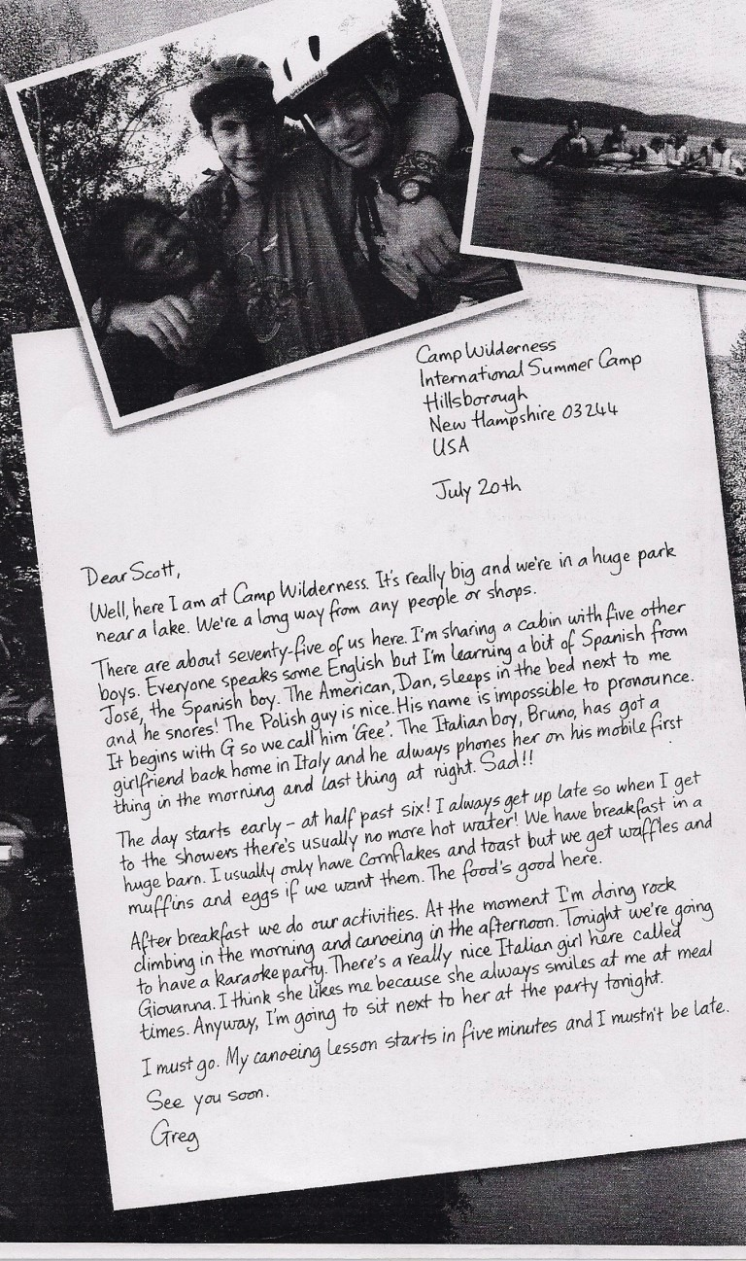
Example: Greg is at an International summer camp. True
It is winter now. False. It is Summer.
1. The camp is very small. _____________________________________________________
2. There is a shop nearby. ______________________________________________________
3. There are five students in Greg's room. _________________________________________
4. Not many people can speak English. ___________________________________________
5. Bruno phones his girlfriend many times a day. __________________________________
6. There is no hot water in the morning. ___________________________________________
7. Greg usually eats waffles and eggs for breakfast. ________________________________
8. Greg is doing rock climbing and canoeing at the moment. ________________________
9. Greg likes an Italian girl called Giovanna. _______________________________________
10. There are about thirty students at the camp. ___________________________________
Now read Tania's letter to her friend Natassa. She is at a camp in the Troodos Mountains. Fill in the missing words in the most suitable way.
(16 marks)
Dear Natassa,
Well, here I am with other students of my age at a holiday __________________ in the Troodos mountains. It's ____________________ here, calm and peaceful and close to ___________________. There aren't any big ___________________ nearby but there's a small shop from _______________ we can buy snacks.There is also a small ______________ further down the road but there is room for only thirty guests. Most of them are _________________ from other European countries.
We are having so much ____________ and we do lots of different ___________________ every day. Our day starts __________________ at about seven in the morning ______________ we all go to the dining area where we have breakfast.
After breakfast we usually go for a ____________________ in the mountains. Then we come __________________ to the camp and we do different ____________________ and sports.
Yesterday, we went mountain biking and then they took us to a _____________ called Platres where we ate lunch at a traditional ___________________. We looked around the area and took many ____________________ of the sights.
We play different _________________ in the afternoon and we organize sports events between teams. I particularly enjoy___________________ basketball and softball. We also do _________________activities which are more creative like drawing and ____________________.
Tomorrow, which is our last day we are ________________ on a day ___________ to Limassol and ___________ the evening we are going to have a ______________.We will also cook______________________ over an open fire.
I have really enjoyed this trip and I am lucky because I _____________ a room with two other girls ______________ are very ______________ and __________________. I am sure we will stay _________________ and _____________ up again.
I have to rush now-see you soon.
Love Tania

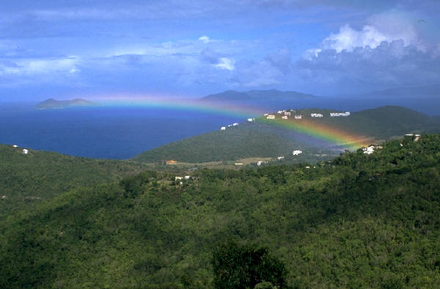
Question 9 (20 marks)
Now write about yourself and your daily routine. You can write about your family, friends, pets, hobbies and interests and something about what you do every day at school and at home.
_____________________________________________________________________________________________________________________________________________________________________________________________________________________________________________________________________________________________________________________________________________________________________________________________________________________________________________________________________________________________________________________________________________________________________________________________________________________________________________________________________________________________________________________________________________________________________________________________________________________________________________________________________________________________________________________________________________________________________________________________________________________________________________________________________________________________________________________________________________________________________________________________________________________________________________________________________________________________________________________________________________________________________________________________________________________________________________________________________________________________________________________________________________________________________________________________________________________________________________________________________________________________________________________________________________________________________________________________
_________________________________________________________________________________________________________________________________________________________________________________________________________________________________________________________________________________________________________________________________________________________________________________________________________________________________________________________________________________________________________________________________________________________________________________________________________________________________________________________________________________________________________________________________________________________________________________________________________________________________________________________________________________________________________________________________________________________________________________________________________________________________________________________________________________________________________________________________________________________________________________________________________________________________________________________________________________________
_______________________________________________________________________________________________________________________________________________________________________________________________________________
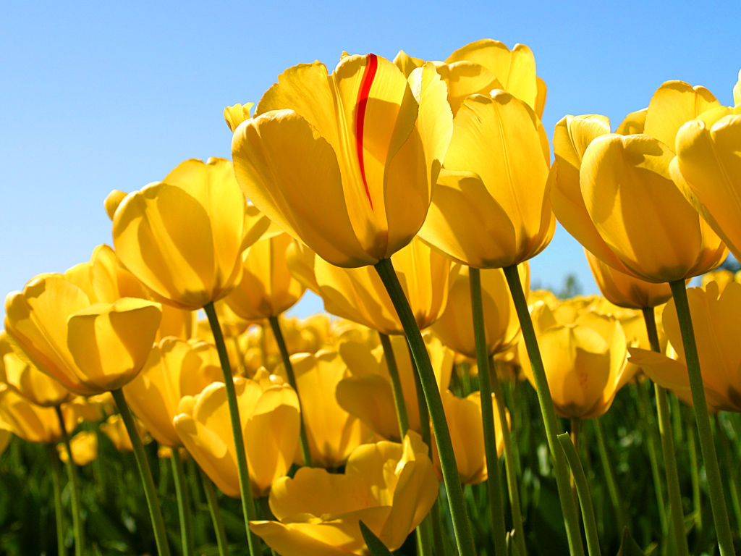 This is the end of the test. Well done!

